Australian Islamic College 2018

ATAR Chemistry Units 3 and 4

Task 11 (Weighting: 5%)

Esters Validation Test

Test Time: 25 minutes

Please do not turn this page until instructed to do so.

First Name | Surname

Teacher

Mark / 26 | Percentage

Equipment allowed: Pens, pencils, erasers, whiteout, rulers and non-programmable calculators permitted by the Schools Curriculum and Standards Authority.

- Which of these molecules is an ester? Circle the correct answer. [1 mark]

  - CH₃CHOHCH₂CH₃
  - CH₃COCH₃
  - CH₃CH₂COOCH₂CH₃
  - CH₃CH₂CHO

- This question relates to the ester shown below.
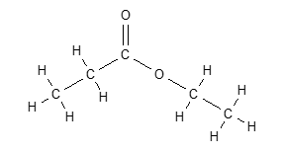

  - Draw the condensed structural formulae and give the names of the two organic molecules that would be required to synthesise this compound. [4 marks]

1.

Name:

2.

Name:

- Methyl salicylate (oil of wintergreen or wintergreen oil) is an organic compound with the formula C₆H₄(OH)(CO₂CH₃). Methyl salicylate was synthesised in the laboratory by combining the appropriate alcohol and carboxylic acid.

  - Show the reaction that occurs during the synthesis of methyl salicylate. Draw structural formulae for all organic reactants and products. [2 marks]

  - The test tube containing the reaction mixture was placed in a beaker of water. The beaker of water was then heated using a Bunsen burner.
      - Suggest why the reaction mixture was not heated directly using the Bunsen burner. [1 mark]

      - What was the purpose of heating the reaction mixture? [1 mark]

  - Write observations for the reaction described above for the synthesis of oil of wintergreen. [2 marks]

  - The reaction mixture was heated in an open test tube, however a better method would be to heat the reaction mixture in the reflux condenser shown below.

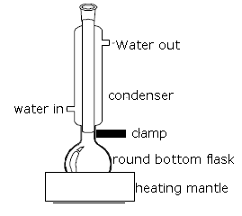
Explain the advantage of synthesising the ester using a reflux condenser. [2 marks]

  - Concentrated sulfuric acid was used as a catalyst. Explain how a catalyst increases reaction rate. [2 marks]

  - An additional benefit of adding concentrated sulfuric acid to the reaction mixture is that it reacts with water in the reaction mixture to form a hydrated form of sulfuric acid, thereby effectively removing water from the reaction mixture. Explain the advantage of removing water from the reaction mixture. [2 marks]

  - Identify two safety hazards associated with the synthesis of oil of wintergreen and for each explain how the risk of that hazard was minimised. [2 marks]

- Esters cannot form hydrogen bonds with other ester molecules but they can form hydrogen bonds with water molecules.

  - Explain why esters cannot form hydrogen bonds with other ester molecules. [1 mark]

  - Draw a diagram to represent a hydrogen bond between methyl ethanoate and water. [2 marks]

- Using structural formulae, write the equation for the saponification of a triglyceride. Show all reactants and products. You may use ‘R’ to represent long hydrocarbon chains. [2 marks; 1 mark off per mistake]

- Name the products A and B produced by the reaction below. [2 marks]

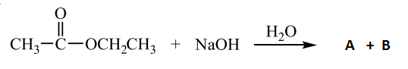

Product A:

Product B:

END OF PAPER

